Renju lesson on October 12, 2000

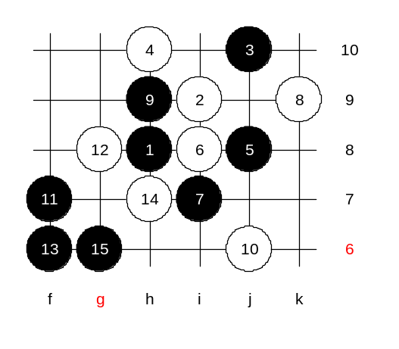
We begin the lesson now. Welcome to the class! Today we will learn the main 4th move of the i1 opening. If we finish that then we can end with this opening and think of new opening. As you probably know, this is the strongest white move in this opening. So please pay attention on today's lesson because today's variants are the most important. We begin with strongest 5th move. Indeed, 5-j8 is the best move. Move 6-i8 one of the choices. Actually 6-j9 is same as 6-i8 because of symmetrical pattern. Yes, moves 6-i8 and 6-j9 are a little different considering the closeness of board edge. But in those variants the edge does not influence black's attack. 7-i7. Move 8-k9 is forced. Any other 8th move would let black take that important k9 point. Yes, moves like 9-h9 serve a tactical purpose - black will block the white line and still keeps all black source active and outside of the pattern. Lets try 10-j6 at first. Can you guess the 11th move? The 11th move is very traditional in such situation and you may have seen such situations quite often in renju games. Yes, f7. Let me explain. This is very important that you understand the real meaning of that move. The reason of the move is not just to play a stone into a space and create two lines (which is also tactically correct), but especially because of the support of j11 point. Let me explain. That means, if white plays next move anywhere but g8 then black will play g8 immediately and force white block from i10 (so passive) and then black can enjoy the space on the left side. So, the conclusion is: in case of such structure, white is forced to play g8. And if you know that white is going to play there then it is easy to count the further development as you don’t have to waste energy on counting the variants other than g8. Actually, as g8 was predictable, so there is also a traditional 13th move there, which always works in such patterns. Where is it? Of course, the 13th move cannot be a three, that’s for sure, because we can see that straight attack does not give any win, and if so, then straight attack is always bad. Actually there are even two good moves possible. In my opinion f6 is the best. Move 13-g6 is also fine. We test white move 14-h7. Move 15-g6 works well together with other black stones beside this. The power of the triangle is that although white has an open diagonal line, black controls it from both ends. So, I suggest that we can close the diagram here. Black is too powerful, and testing possible 16th moves can be everyone's personal study.

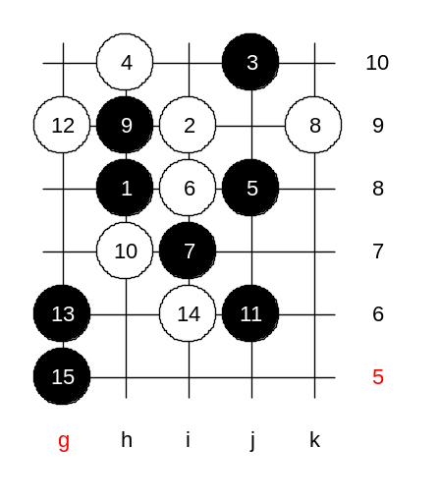
We change the 10th move. Move 10-h7 is the strongest possible move here. By the way, I have a question. How many of you recognize that we have studied similar pattern before. The different sequence and rotated by 90 degrees. We studied it last week. According to the similarity, black should play j9 and then g12. Then it would follow the attacking steps that you learned last week. But here is one difference. Upper edge is too close and black cannot attack here in same way, because of smaller space. Therefore black has to use another attacking method that develops attack towards lower side where is more space. By the 15th move black wins, because of sufficient space in lower side. Let us rotate the position by choosing another 6th move and you see the difference.

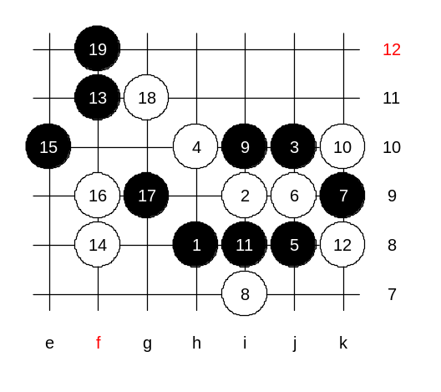
Move 6-j9 this time. After 9-i10 the position is identical with the variant that you learned last week. (There the sequence was 4-i7, 5-i10).
10-k10. This is similar to what we just studied on previous diagram. But the position is shifted and here the 11-L8 and 13-L11 does not work because of insufficient space on the right side. But that’s not the problem, because black can attack as I taught you last week. Lets see who remembers it. Tell me the moves. That’s it. We got exactly the same position as last week.

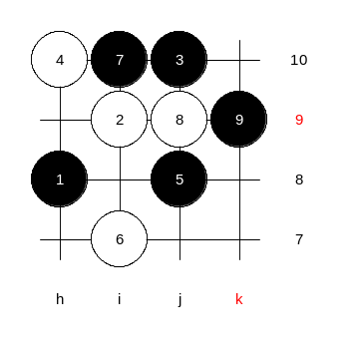
Another 6th move now. 6-i7. Where is black move? If black plays i8 then black stones will be inside and surrounded. Move i10 is the best. White will play 8-j9.
And the 9th move is...? :) Yes! k9 it is, and all goes to same place we just came from.
As there are no other possible 6th moves left, we have finished learning the 5th move.

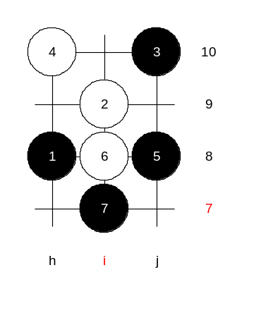
Let me give you homework question. We will have two homework positions. Medium level homework: Please find black win after 8-g9. Advanced level homework:
Please find black win after 8-j6. Is the homework question clear or we need another diagram for this? Now, the class is over. Thank you all for coming here today. I wish you all a good day (night). See you next Thursday!

